**About sharp ratio**

Since William Sharpe's creation of the Sharpe ratio in 1966, it has been one of the most referenced risk/return measures used in finance, and much of this popularity is attributed to its simplicity. The ratio's credibility was boosted further when Professor Sharpe won a Nobel Memorial Prize in Economic Sciences in 1990 for his work on the capital asset pricing model (CAPM).

So, any investment you make is going to come with some sort of risk. It's natural to wonder how much your investment will really benefit you. Before you dive into a new venture, you'll want to know whether the time and money you put in will be worthwhile in the end.

This is where the Sharpe ratio comes in handy. Measuring investment returns and risk, the calculation is widely used among professional investment managers. It's important to understand the Sharpe ratio and what it can teach you about your money.

The Sharpe ratio helps you determine whether the risk you've taken on has paid off in your returns, compared to the returns you might have seen without taking on risk.

One way to increase your Sharpe ratio is to have a [diversified portfolio](https://www.businessinsider.com/personal-finance/how-to-diversify-portfolio). A main concept of modern portfolio theory, diversification and asset allocation ensure slow steady growth over time and help your portfolio weather the ups and downs of the markets.

To calculate the Sharpe ratio, you first need your portfolio's **rate of return**.

Next, you need the **rate of a risk-free investment,** such as [Treasury bonds](https://www.businessinsider.com/personal-finance/how-to-buy-treasury-bonds). Subtract this risk-free rate from your portfolio's rate of return to find the excess return, or what your investment gives you above the Treasury bond.

Finally, you divide the difference of those two components by the **standard deviation of the portfolio's excess return**.

Here's what the equation looks like:

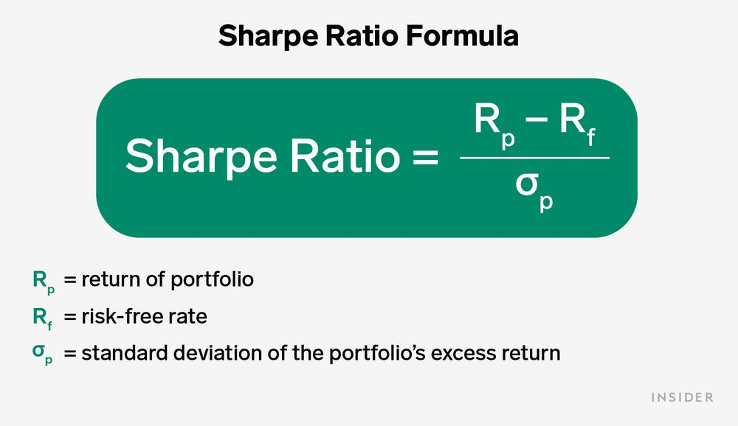

**Return of portfolio:** This is what your portfolio has earned, or what you expect to earn, over a given amount of time as a percentage of what you have invested.

**Risk-free rate:** This figure acts as your benchmark, or what you would've earned without virtually any risk. The Sharpe ratio often uses Treasury securities here because of their unlikeliness to default. For example, you might use a 5-year Treasury note rate to calculate the Sharpe ratio for your 5-year portfolio.

**Standard deviation:** This measurement of volatility indicates how much a return fluctuates over a period of time. Expressed as a positive number, the [standard deviation](https://www.businessinsider.com/personal-finance/what-is-standard-deviation) accounts for both downside and upside changes.

The Sharpe ratio helps you determine whether the risk you've taken on has paid off in your returns, compared to the returns you might have seen without taking on risk.

Most finance people understand how to calculate the Sharpe ratio and what it represents. The Sharpe ratio compares the return of an investment with its risk. It's a mathematical expression of the insight that excess returns over a period of time may signify more volatility and risk, rather than investing skill.  
Economist William F. Sharpe proposed the Sharpe ratio in 1966 as an outgrowth of his work on the capital asset pricing model (CAPM), calling it the reward-to-variability ratio.

Risk and reward must be evaluated together when considering investment choices; this is the focal point presented in Modern Portfolio Theory. In a common definition of risk, the standard deviation or variance takes rewards away from the investor. As such, always address the risk along with the reward when choosing investments. The Sharpe ratio can help you determine the investment choice that will deliver the highest returns while considering risk.

LINKOVI:  
[Sharpe Ratio: Definition, Formula, How to Use It (businessinsider.com)](https://www.businessinsider.com/personal-finance/sharpe-ratio)

[Understanding the Sharpe Ratio (investopedia.com)](https://www.investopedia.com/articles/07/sharpe_ratio.asp)